Superstore Analysis

By Alen Birindzic

# Executive Summary

This document provides a comprehensive analysis of the superstore’s performance, focusing on underperforming product categories, customer and product performance, and future forecasts for the Consumer segment. Key findings include significant underperformance in certain product categories, valuable insights into customer demographics and regional sales trends, and a stable profit outlook with variable demand forecasts. Based on these insights, we recommend targeted marketing campaigns, optimizing discount strategies, and improving inventory management to enhance profitability and customer satisfaction.

# Introduction

## Purpose and Scope of the Analysis

The purpose of this analysis is to provide a detailed understanding of the superstore's performance, identifying key areas of improvement and offering actionable recommendations. This document covers three main areas: the performance of underperforming product categories, an overview of customer and product performance, and a forecast for future trends using the Consumer segment as a focus.

## Objectives and Goals

The primary objectives of this analysis are to:

* Identify and analyze underperforming product categories.
* Understand customer demographics and product performance.
* Forecast future trends to help the superstore prepare for upcoming changes.

## Methodology

This analysis was conducted using Power BI and Python (with Prophet). Power BI was used to create detailed dashboards for visualizing performance metrics and trends, while Python’s Prophet library was used for forecasting future trends.

# Performance Analysis of Underperforming Product Categories

The dashboard indicates significant underperformance in certain product categories, with key metrics and visualizations highlighting areas of concern.

**Key Metrics:**

* **Total Sales:** $369K
* **Total Profit:** -$22K (indicating a loss)
* **Total Discount:** $68K
* **Profit Margin:** -6%

**Sales, Discount, and Profit by Month:**

* The bar chart shows monthly sales, discounts, and profits.
* Sales peak in September ($49K) and November ($58K), but profits are negative in several months, notably October (-$2K) and December (-$2K).

**Profitable Products:**

* The treemap highlights the most profitable products, with "Atlantic Met" leading at $780.
* Other notable products include "SAFCO P" ($608), "O'Sulliva" ($566), and "Hon N" ($542).

**Quantity by Year and Region:**

* The waterfall chart shows quantity changes by year and region.
* The East region in 2017 shows the highest increase (858), while the West region in 2014 shows a decrease (-19).

**Regional Performance:**

* The dashboard categorizes performance by regions: Central, East, South, and West.
* The East region shows significant activity, while other regions have less pronounced performance metrics.

**Recommendations:**

1. **Investigate Losses:** Analyze why profits are negative despite high sales in certain months.
2. **Discount Strategy:** Reevaluate the discount strategy, as high discounts ($68K) may be contributing to the negative profit margin.
3. **Focus on Profitable Products:** Increase focus on top-performing products like "Atlantic Met" and "SAFCO P" to boost overall profitability.
4. **Regional Analysis:** Conduct a deeper regional analysis to understand why the East region is performing better and replicate successful strategies in other regions.

# Customer & Product Performance Analysis

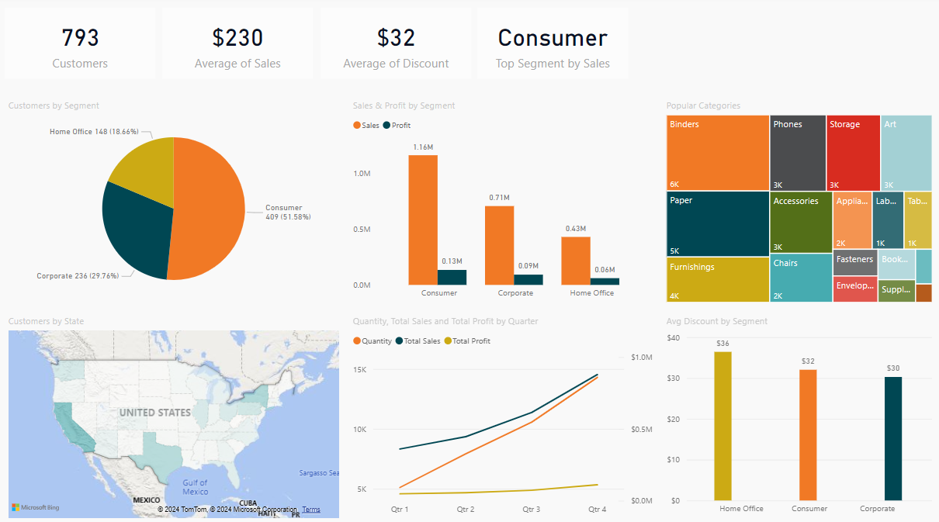

The "Customer & Product Overview" dashboard provides a comprehensive snapshot of customer demographics and product performance, highlighting key metrics, sales trends, and product popularity.

**Key Metrics:**

* **Total Customers:** 793
* **Average Sales per Customer:** $230
* **Average Discount per Customer:** $32
* **Top Segment by Sales:** Consumer

**Customers by Segment:**

* **Consumer:** 409 customers (51.58%)
* **Corporate:** 236 customers (29.76%)
* **Home Office:** 148 customers (18.66%)

**Sales and Profit by Segment:**

* **Consumer:** $1.16M in sales, $0.13M in profit
* **Corporate:** $0.71M in sales, $0.09M in profit
* **Home Office:** $0.43M in sales, $0.06M in profit

**Popular Categories:**

* Key product categories by sales volume include:
  + Binders
  + Phones
  + Storage
  + Art
  + Paper
  + Accessories

**Customers by State:**

* **California:** 577 customers
* **Washington:** 224 customers
* **Texas:** 370 customers
* **New York:** 415 customers
* **Pennsylvania:** 257 customers
* **Ohio:** 202 customers
* **Illinois:** 237 customers

**Quarterly Trends:**

* **Quantity Sold, Total Sales, and Total Profit**:
  + The line chart indicates trends over four quarters, helping identify seasonal patterns and sales performance.

**Average Discount by Segment:**

* **Home Office:** $36
* **Consumer:** $32
* **Corporate:** $30

**Refined Recommendations:**

1. **Focus on High Customer States:** Given the significant customer base in California, Texas, and New York, implement targeted marketing campaigns in these states to boost sales and customer engagement.
2. **Enhance Consumer Segment Strategies:** The Consumer segment is the largest and most profitable. Tailored promotions and loyalty programs could further increase sales and retention in this segment.
3. **Reevaluate Discounts:** The Home Office segment receives the highest average discount. Adjust discount strategies to ensure they drive sales without negatively impacting profits.
4. **Leverage Popular Categories:** Invest in high-performing product categories like Binders and Phones, potentially expanding their range or improving inventory management.
5. **Regional Campaigns:** Utilize the customer distribution data to execute region-specific promotions and initiatives in underperforming areas to increase market penetration.

# Consumer Segment Profit and Demand Forecast Analysis

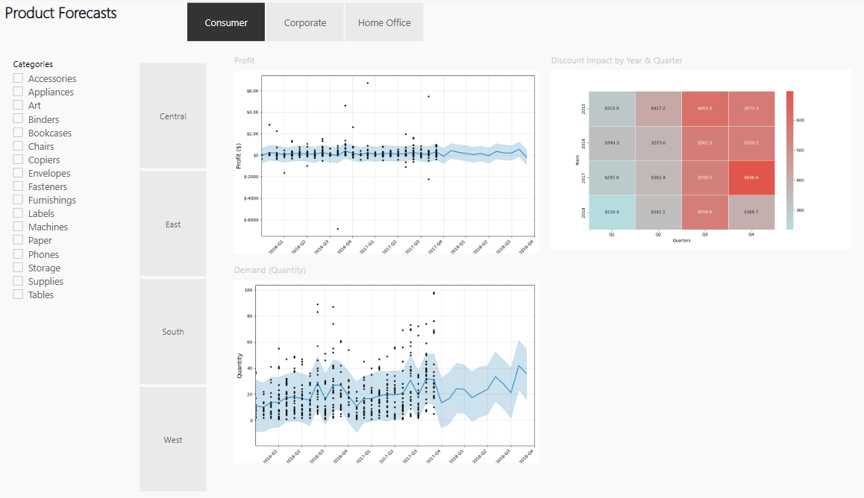

The "Product Forecasts" dashboard offers projections of future trends, helping the superstore anticipate and prepare for upcoming changes in profitability and demand.

**Key Metrics:**

* **Profit Forecast**:
  + The profit forecast chart predicts a relatively stable profit trend with slight fluctuations over the quarters from 2016 to 2020.
  + The confidence interval suggests some variability, but overall profit is expected to remain within a predictable range.
* **Demand Forecast**:
  + The demand forecast chart shows more variability in the quantity of products demanded, with noticeable peaks and troughs.
  + This indicates that while demand can be somewhat unpredictable, there are periods of higher and lower demand that the store should prepare for.
* **Discount Impact by Year & Quarter**:
  + The heatmap reveals significant variation in the impact of discounts across different periods.
  + Notably, the fourth quarter of 2020 shows a high discount impact, indicating that discounts during this period substantially affect sales.

**Recommendations:**

1. **Monitor Profit Trends**:
   * Given the relatively stable profit forecast, the store should monitor any deviations from the predicted trend to take corrective actions promptly.
2. **Prepare for Demand Fluctuations**:
   * The variability in demand necessitates flexible inventory management. The store should ensure stock levels can accommodate periods of high demand and avoid overstocking during low demand periods.
3. **Optimize Discount Strategies**:
   * The heatmap highlights the importance of strategic discounting. Analyzing periods with high discount impact can help optimize future discount strategies, ensuring they are applied during times when they can maximize sales and profit.

# Conclusion

The analysis has provided valuable insights into the superstore's operations, highlighting areas of concern and opportunities for growth. Key findings include significant underperformance in certain product categories, valuable insights into customer demographics and regional sales trends, and a stable profit outlook with variable demand forecasts. To address these issues, we recommend focusing on high-customer states with targeted marketing campaigns, optimizing discount strategies, and improving inventory management. By implementing these recommendations, the superstore can enhance profitability, improve customer satisfaction, and better prepare for future trends.